Documentation

App prototype <https://median.co/app/41xx2n4xhd9g3edhd7m7r3zkyw/build#app-download>

React expo <https://docs.expo.dev/distribution/uploading-apps>

<https://medium.com/makedeveasy/convert-website-into-app-using-react-native-expo-publish-in-the-app-store-6979d47886c3#:~:text=In%20this%20article%2C%20we%20will,publish%20in%20the%20Playstore%2FAppStore>

Android studio <https://youtu.be/Lmx2-0HBx5A?feature=shared>

<https://youtu.be/GhuiNcOEv1A?feature=shared>

[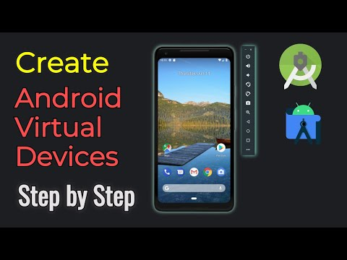](https://youtu.be/GhuiNcOEv1A?feature=shared)

[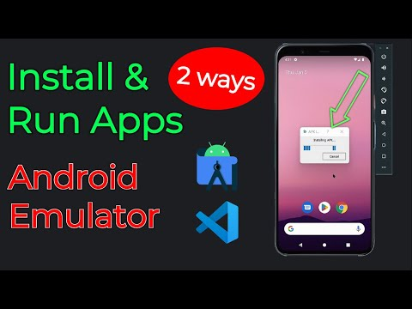](https://youtu.be/Lmx2-0HBx5A?feature=shared)

Location data is strange on the school computers due to the blocks the district has in place, if you are testing for location accuracy you must use the cyber computers or your personal computer/ phone

Here is the link to my replit of some of the website code. We do not know if it updates with the website

<https://replit.com/@boibodybo/thang>

<https://replit.com/join/eituaxjxdb-boibodybo>

We have run into issues with API keys

<https://www.docusign.com/blog/developers/the-trenches-how-to-use-api-logs>

<https://developer.squareup.com/docs/devtools/api-logs>

Can use this to look at Api keys <https://www.postman.com/>

You need android studio or VS code to run the app relace

Client information

Point of contact [becky@emergencare.com](mailto:becky@emergencare.com)

brian@emergencare.com [<brian@emergencare.com](mailto:<brian@emergencare.com)>